 |  | Core text used | in English
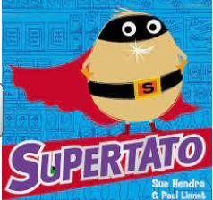 | 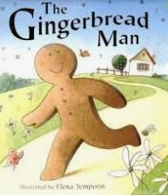 | 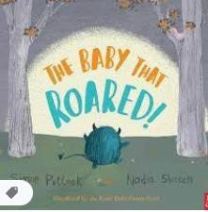 | 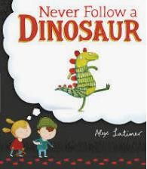 |  | 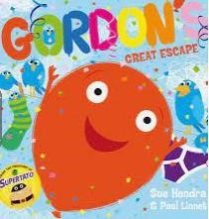 |  | 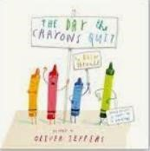
Supertato By Sue Hendra | The Gingerbread Man By Mairi Mackinnon | The Baby who Roared By Simon Puttock | Never Follow a Dinosaur By Alex Latimer |  | Gordons Great Escape By Sue Hendra |  | The day the Crayons Quit By Oliver Jeffers
Writing focuses  Narrative  Instructions | Writing focuses  Narrative  Instructions | Writing focuses  Narrative  Recount - Diary entry | Writing focuses  Narrative  Non-chronological report |  | Writing focuses  Narrative  Non-chronological report |  | Writing focuses  Narrative  Recount
 |  | Core text used across | the curriculum
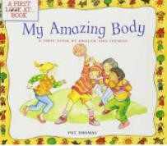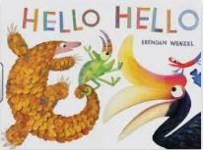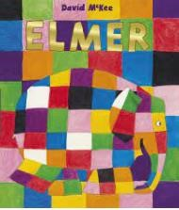 | 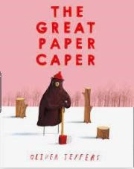 | 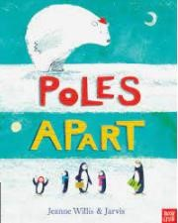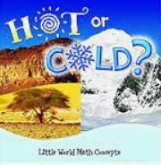 | 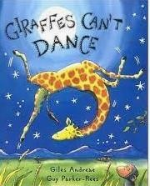 |  | 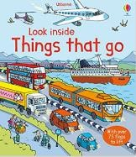 |  | 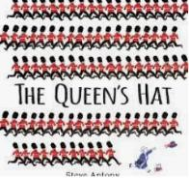
My Amazing body  By Pat Thomas  Diversity books – Elmer  Hello, Hello | The great Paper Caper  By Oliver Jeffers | Poles apart  By Jeanne Willis  Hot or cold  By Barbara Webb Diversity books – My world, your world | Giraffes can’t Dance By Giles Andreae |  | Dogger  By Shirley Hughes  Things that go  Usborne  Diversity books – The family book. |  | The queens Hat  By Steve Antony  Cameron can too By Allie Brooke
Science | DT/Science | Geography | Science |  | History DT |  | Geography History
 |  | The 5 Plagues of the Developing Reader*
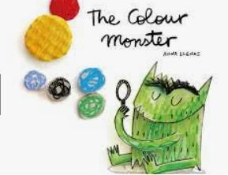 | 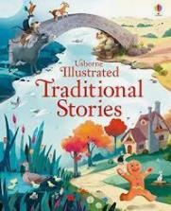 | 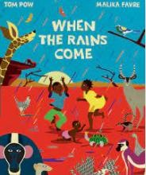 | 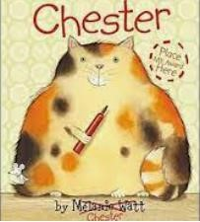 | 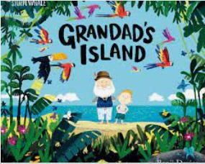
Resistant text  Colour Monster  Anna Llenas | Archaic Texts  Traditional Stories Various Authors | Non-Linear time Sequences  When the Rains Come Tom Pow | Complexity of the Narrator  Chester  Melanie Watt | Complexity of the plot/symbol  Grandpa’s Island  Benji Davies
Curriculum Drivers | Curriculum Drivers  Resilience- bravery Community – different types of families. | Curriculum Drivers  Resilience - bravery  Community – being part of a small community  Aspiration – to support the community | Curriculum Drivers  Community - friendships | Curriculum Drivers  Community - family  Resilience - dealing with grief
 |  | Autho | r Study
Sue Hendra | Tony Ross | Martin Waddell | Jill Murphy | Ian Whybrow |  | Mick Inkpen
 |  | Po | etry
What we found at the seaside  Kate Williams | Snowball  Shel Silverstein | What is Pink? Christina Rossetti | Where teachers keep their pets  Paul Cookson | Grandma’s Glasses |  | Nut tree Julia Donaldson
*The 5 Plagues of the Developing Reader https://teachlikeachampion.com/wp-content/uploads/5-Plagues-Reading-Spine.pdf
The order in which texts are studied may change.

