 |  | Core text used | in English
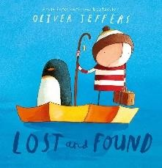 | 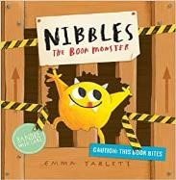 | 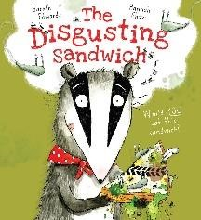 | 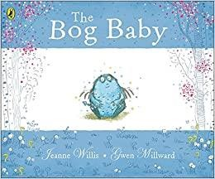 |  |  | 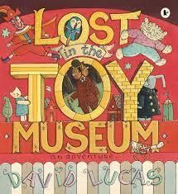 |  | 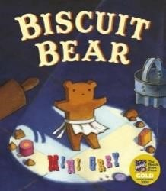
Lost and Found By Oliver Jeffers | Nibbles the Book Monster By Emma Yarlett | The Disgusting Sandwich By Gareth Edwards | The Bog Baby By Jeanne Willis |  |  | Lost in the Toy Museum by David Lucas |  | Biscuit Bear by Mini Grey
Writing focuses  Narrative  Recount | Writing focuses  Narrative  Recount | Writing focuses  Narrative  Instructions | Writing focuses  Narrative  Non-Chronological Report |  |  | Writing focuses  Narrative  Non-Chronological Report |  | Writing focuses  Narrative  Instructions
 |  | Core text used across | the curriculum
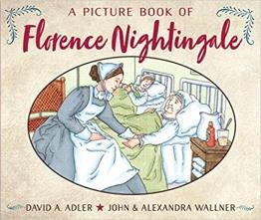 | 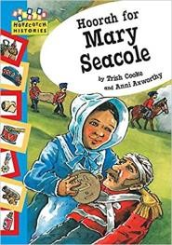 | 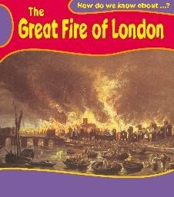 | 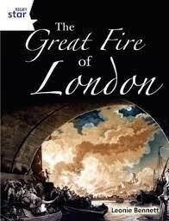 |  |  | 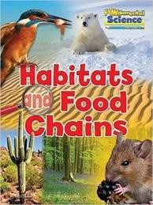 |  | 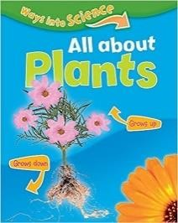
A Picture book of  Florence Nightingale By David A Adler | Hooray for Mary Seacole  (hopscotch: Histories)  By Trish Cooke | The Great Fire of London | The Great Fire of London by Leonie Bennet |  |  | Habitats and Food Chains Fundamental Science |  | (ways into Science) All about Plants  By Peter Riley
History | Black History Month | History | History |  |  | Science |  | Science
 |  | Class Novels
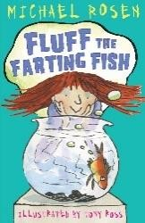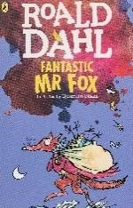 | 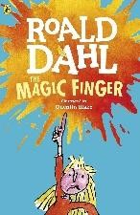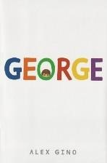 | 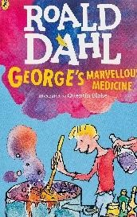 |  | 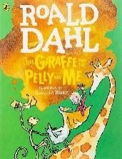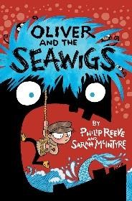 | 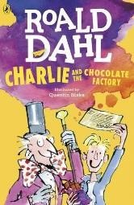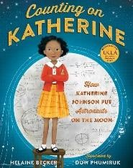 |  | 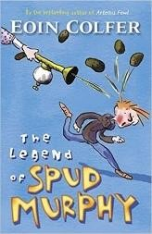
Fluff the Farting Fish  By Michael Rosen  Fantastic Mr Fox  By Roald Dahl | George  By Alex Gino  The Magic Finger By Roald Dahl | George’s Marvellous Medicine By Roald Dahl |  | Oliver and the Seawigs  By Philip Reeve and Sarah  MCIntyre  The Giraffe, the Pelly and  Me  By Roald Dahl | Counting on Katherine  By Helaine Becker  Charlie and the Chocolate  Factory  By Roald Dahl |  | The Legend of Spud Murphy By Eoin Colfer
Curriculum Drivers  Resilience- bravery and justice. | Curriculum Drivers  Community- prejudice and treating others differently.  Resilience- bravery and justice.  Aspiration – Challenging stereotypes | Curriculum Drivers  Resilience - bravery  Community – friendship, poverty |  | Curriculum Drivers  Resilience - bravery  Community – friendship | Curriculum Drivers  Aspiration - Challenging stereotypes  Community - family and diversity  Resilience - persevering to make a difference |  | Curriculum Drivers  Community – family life  Resilience - persevering to make a difference
 |  | Author |  | Study
Roald Dahl |  | Lauren Child |  | Nick Butterworth | Julia Donaldson
 |  |  |  | Poetry
 |  | Funky Chickens By Benjamin Zephaniah |  |  | Revolting Rhymes By Roald Dahl

*The 5 Plagues of the Developing Reader https://teachlikeachampion.com/wp-content/uploads/5-Plagues-Reading-Spine.pd

Archaic Language | The Magic Far Away Tree by Enid Blyton
Non-Linear Time Sequences | Voices in the Park by Antony Brown
Narratively complex | Fantastic Mr Fox by Roald Dahl
Figurative/Symbolic Text | The Heart and the Bottle by Oliver Jeffers
Resistant Text | Lost and Found by Oliver Jeffers

The order in which texts are studied may change.

