Core text used in English
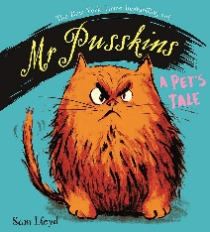 | 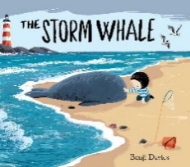 | 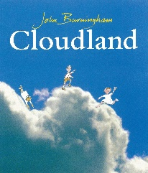 |  |  |  | 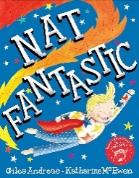 |  | 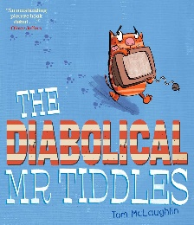 |  |  |  | 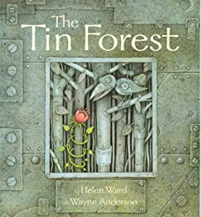
Mr Pusskins  by Sam Lloyd | The Storm Whale  by Benji Davies | Cloudland  by John Burningham |  |  |  | Nat Fantastic  by Giles Andreae |  | The Diabolical Mr Tiddles  by Tom McLaughlin |  |  |  | The Tin Forest  by Helen Ward
Writing focuses  Narrative  Recipe | Writing focuses  Narrative  Non-Chronological Report | Writing focuses  Narrative  Instructions |  |  |  | Writing focuses  Narrative  Recount (diary) |  | Writing focuses  Narrative  Explanation |  |  |  | Writing focuses  Narrative  Non-Chronological Report
Core text used across the curriculum

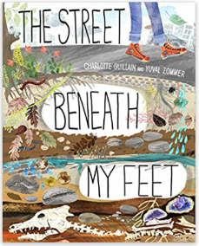 | 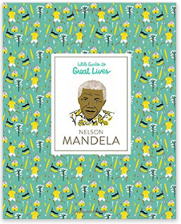 |  |  | 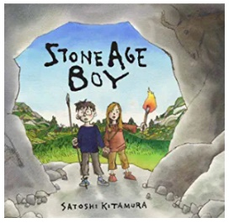 | 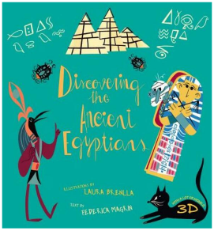 |  |  |  | 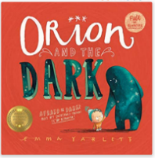  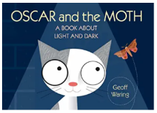 |  |  | 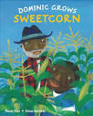  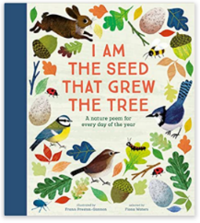
The Street Beneath my Feet  by Charlotte Guillian | Little Guided to Great Lives: Nelson Mandela |  |  | The Stone Age Boy  by Satoshi Kitamura | Discovering the Ancient Egyptians  by Federica Magrin |  |  |  | Orion and The Dark  by Emma Yarlett  Oscar and the Moth  by Geoff Waring |  |  | I am the seed that grew the tree (poetry)  by Fiona Waters  Dominic Grows Sweetcorn  by Mandy Ross
Geography/Science | Black History Month |  |  | History | History |  |  |  | Science |  |  | Science
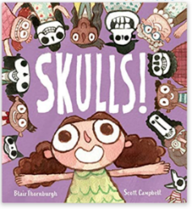 | 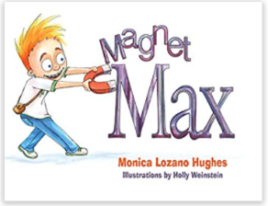 |  |  | 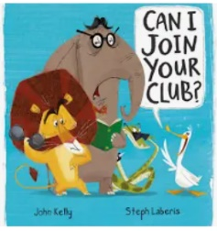 | 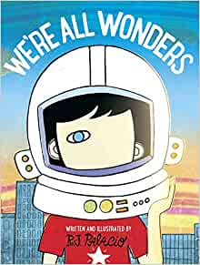 |  |  |  | 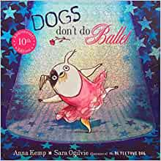 |  |  | 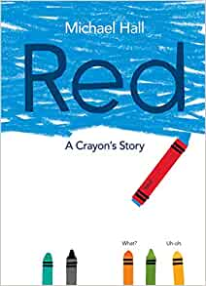
Skulls  by Blair Thornburgh | Magnet Max  by Monica Lozano Hughes |  |  | Can I Join Your Club?  by John Kelly and Steph Laberis | We’re all Wonders  by R J Palacio |  |  |  | Dogs don’t do ballet  by Anna Kemp and Sarah Oglivie |  |  | Red: A crayon’s story  by Michael Hall
Science | Science |  |  | PSHE - Diversity | PSHE - Diversity |  |  |  | PSHE - Diversity |  |  | PSHE - Diversity
Class Novels

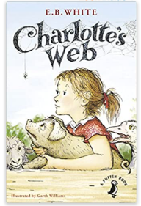 | 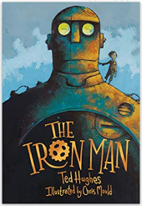 | 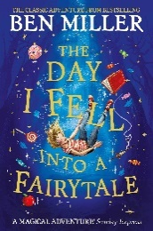 |  |  |  | 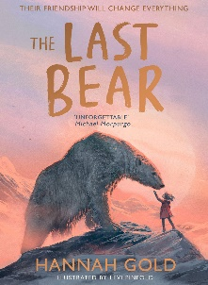 |  | 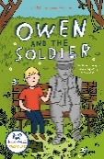 |  |  |  | 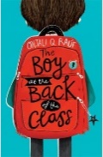
Charlotte’s Web*  by E. B. White | The Iron Man  by Ted Hughes * | The Day I fell into a fairy tale  by Ben Miller |  |  |  | The Last Bear  by Hannah Gold |  | Owen and the Stone Soldier  by Lisa Thompson |  |  |  | The Boy at the Back of the Class by Onjali Rauf
Curriculum Drivers  Resilience - bravery  Community - teamwork | Curriculum Drivers  Community- prejudice and treating others differently.  Resilience- bravery and justice. | Curriculum Drivers  Resilience - courage  Community - friendship |  |  |  | Curriculum Drivers  Aspiration - Making a difference |  | Curriculum Drivers  Aspiration  Community - family and diversity  Resilience - persevering to make a difference |  |  |  | Curriculum Drivers  Aspiration  Community - refugee  Resilience - persevering to make a difference
Author Study

Allan Ahlberg* | Tom Percival | Mini Grey |  |  |  | Paula Harrison |  | Barbara Mitchelhill |  | Michael Rosen (poet)
Poetry
Topsy-Turvy World* | A Big Surprise  Michaela Morgan |  | Scissors  Allan Ahlberg |  |  | New School  Kevin McCann | Walking with my Iguana  Brian Moses |  |  |  | Homework! Oh, Homework! Jack Prelutsky

*The 5 Plagues of the Developing Reader https://teachlikeachampion.com/wp-content/uploads/5-Plagues-Reading-Spine.pdf
Archaic Language | Charlotte’s Webb by E.B. White
Non-Linear Time Sequences | Dominic Grows Sweetcorn by Mandy Ross
Narratively complex | Woof by Allan Ahlberg
Figurative/Symbolic Text | The Iron Man by Ted Hughes
Resistant Text | Topsy-Turvy World (poem)

The order in which texts are studied may change.

