Core text used in English
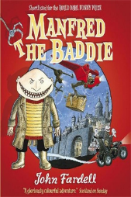 |  | 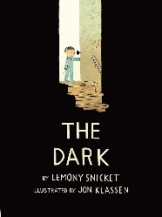 |  | 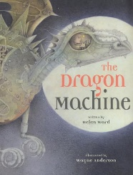 |  | 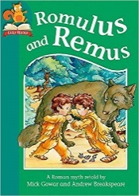 |  |  | 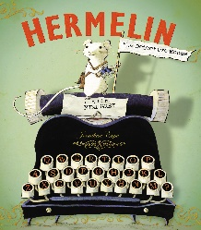 |  |  |  | 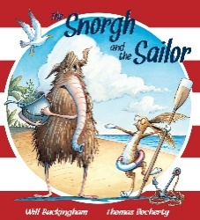
Manfred the Baddie  by John Fardell |  | The Dark  by Lemony Snicket |  | The Dragon Machine  by Helen Ward  Tell Me a Dragon  By Jackie Morris |  | Romulus and Remus  by Mick Gowar and Andrew Breakspeare |  |  | Hermelin  by Minnie Grey |  |  |  | The Snorgh and the Sailor  by Will Buckingham
Writing focuses  Narrative  Explanation |  | Writing focuses  Narrative  Persuasion |  | Writing focuses  Narrative  Non-Chron report |  | Writing focuses  Myths and Legends  Instructions |  |  | Writing focuses  Narrative  Recount (Newspaper) |  |  |  | Writing focuses  Narrative  Recount (Dairy)
Core text used across the curriculum

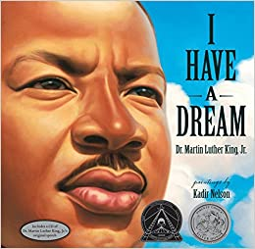 | 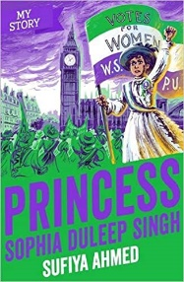 |  | 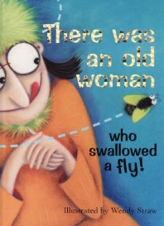 |  | 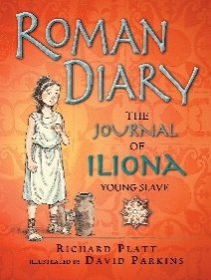 |  | 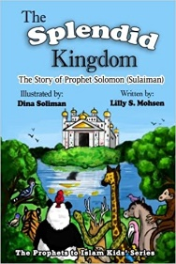 |  |  | 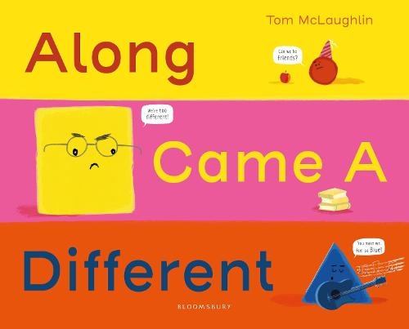 |  |  |  | 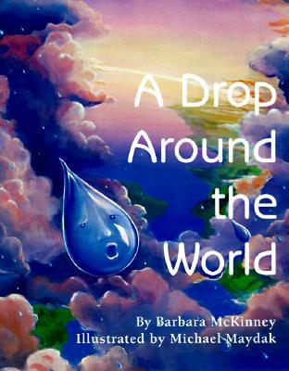
I Have a Dream  by Martin Luther King Jr. | Princess Sophia Duleep Singh  by Sufiya Ahmed |  | There was an Old Woman Who Swallowed a Fly |  | The Journey of Iliona  by Richard Platt |  | The Splendid Kingdom: The story of Prophet Solomon  by Lilly S. Mosen |  |  | Along Came A Different  by Tom McLaughlin |  |  |  | A Drop Around the World  by Barbara Shaw McKinney
Black History Month | History |  | Science |  | History |  | History |  |  | PSHE (Diversity) |  |  |  | Science/Geography
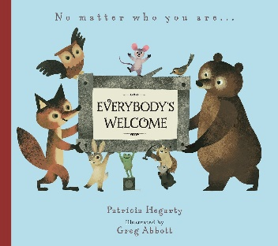 |  |  |  |  | 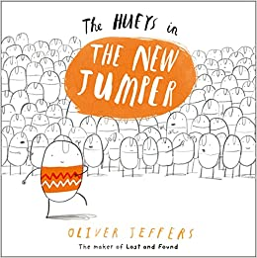
No Matter Who You are Everyone’s Welcome  by Patricia Hegarty |  |  |  |  | The Hueys in the New Jumper  by Oliver Jeffers
PSHE |  |  |  |  | PSHE
Class Novels

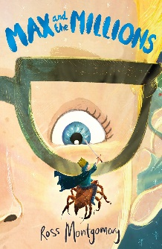 |  | 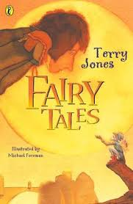 |  | 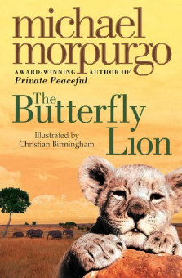 |  | 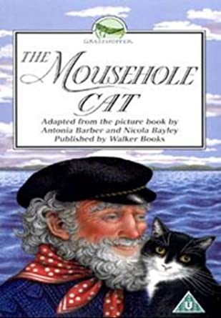 |  |  | 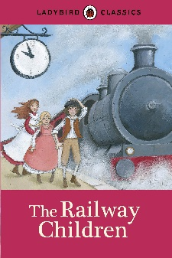 |  |  |  | 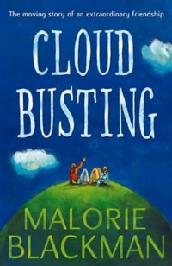
*Max and the Millions  by Ross Montgomery |  | Fairy Tales  by Terry Jones |  | *The Butterfly Lion  by Michael Morpurgo |  | *The Mousehole Cat  by Antonia Barber |  |  | *The Railway Children  by Edith Nesbit |  |  |  | *Cloud Busting  by Malorie Blackman
Curriculum Drivers  Resilience – perseverance to improve oneself  Community – helping others |  | Curriculum Drivers  Resilience- bravery and justice. |  | Curriculum Drivers  Resilience - persevering |  | Curriculum Drivers  Resilience - sacrifice and bravery |  |  | Curriculum Drivers  Resilience - persevering and bravery  Community – befriending local people |  |  |  | Curriculum Drivers  Aspiration - to achieve  Community - friendship
Author Study

Anne Fine | Dick King-Smith |  |  | Michael Morpurgo |  | Jeff Brown |  |  | Jeff Kinney |  | Malorie Blackman
Poetry
Hot Food  by Michael Rosen | A Small Dragon  by Brian Patten |  |  | There was an Old Woman Who Swallowed a Fly |  | The Spirit of Place  by Richard Brown |  | The Music Lesson Rap  by Clare Bevan |  |  |  | Cloud Busting  by Malorie Blackman
*The 5 Plagues of the Developing Reader https://teachlikeachampion.com/wp-content/uploads/5-Plagues-Reading-Spine.pdf
Archaic Language | The Railway Children by Edith Nesbit
Non-Linear Time Sequences | The Butterfly Lion by Michael Morpurgo
Narratively complex | Max and the Millions by Ross Montgomery  by Ross Montgomery
Figurative/Symbolic Text | The Mousehole Cat by Antonia Barber
Resistant Text | Cloud Busting by Malorie Blackman

The order in which texts are studied may change.

