Core text used in English
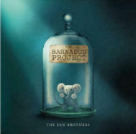 | 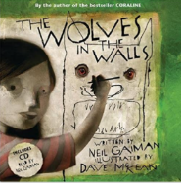 |  |  | 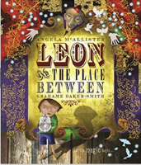 |  |  | 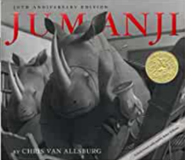 |  |  | 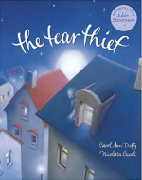 |  |  |  |  | 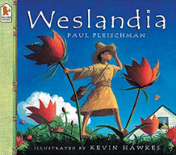
The Barnabus Project  by The Fan Brothers | Wolves in the walls  by Neil Gaiman |  |  | Leon and the place between  by Angela McAllister |  |  | Jumanji  by Chris Van Allsburg |  |  | The Tear Thief  by Carol Ann Duffy |  |  |  |  | Weslandia  by Paul Fleischman
Writing focuses  Narrative  Discussion | Writing focuses  Narrative  Recount (newspaper report) |  |  | Writing focuses  Narrative  Instructions |  |  | Writing focuses  Narrative  Explanation |  |  | Writing focuses  Narrative  Recount (diary) |  |  |  |  | Writing focuses  Narrative  Persuasion / non chronological report
Core text used across the curriculum

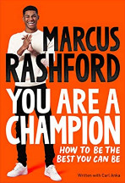 | 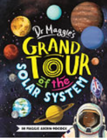  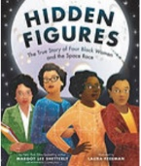 |  | 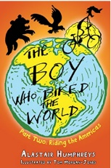 |  | 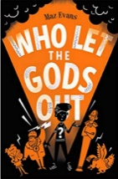 |  |  | 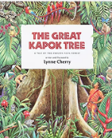  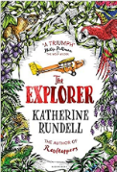 |  |  | 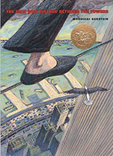 |  |  |  |  | 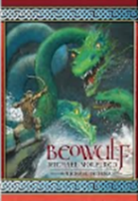  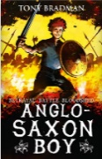
You Are a Champion  Marcus Rashford | Grand Tour of the Solar System  by Dr Maggi  Hidden Figures  by Laura Freeman |  | The Boy Who Biked The World Part 2: Riding the Americas  by Alastair Humphreys |  | *Who Let the Gods Out?  by Maz Evans |  |  | The Explorer  by Katherine Rundell  The Great Kapok Tree  by Lynne Cherry |  |  | The Man Who Walked Betweeen the Towers  by Mordicai Gerstein |  |  |  |  | Beowulf  Michael Morpurgo  Anglo Saxon Boy  by Tony Bradman
History | Science |  | Geography |  | History |  |  | Geography |  |  | Science |  |  |  |  | History
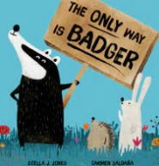 |  | 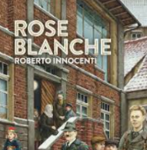 |  |  |  | 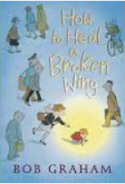 |  |  |  |  |  | 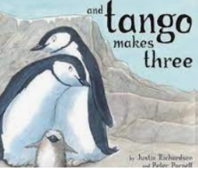
The only way is badger  by Stella Jones / Carmen Salda |  | Rose Blanche  by Roberto Innocenti |  |  |  | How to heal a broken wing  by Bob Graham |  |  |  |  |  | And Tango makes three  by Justin Richardson / Peter Parnell
PSHE |  | PSHE |  |  |  | PSHE |  |  |  |  |  | PSHE
Class Novels

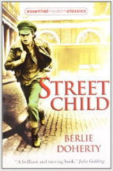 | 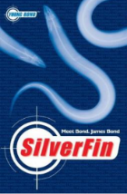 |  |  | 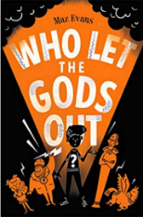 |  |  | 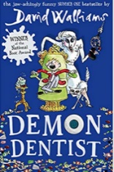 |  |  | 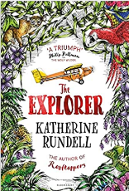 |  |  |  |  | 
Street Child  by Berlie Doherty | *Silverfin  by Charlie Higson |  |  | Who let the gods out?  by Maz Evans |  |  | Demon Dentist  by David Walliams |  |  | The Explorer  by Katherine Rundell |  |  |  |  | *Below Zero  by Dan Smith
Curriculum Drivers  Resilience  Aspiration  Community | Curriculum Drivers  Resilience  Aspiration |  |  | Curriculum Drivers  Resilience  Community  Aspiration |  |  | Curriculum Drivers  Community |  |  | Curriculum Drivers  Resilience  Community  Aspiration |  |  |  |  | Curriculum Drivers  Resilience  Community  Aspiration
Author Study

Liz Pichon | Beast Quest / Adam Blade |  |  | Jacqueline Wilson |  |  | David Walliams |  |  | David Walliams |  |  | Zanib Mian
Poetry
This is the place  Tony Walsh | You can’t be that  Brian Patten |  |  | *The Tyger  William Blake |  |  | * The Highwayman  Alfred Noyes |  | The Emperor’s Watchmaker  Lemn Sissay |  |  |  |  | The dragon who ate our school  Nick Toczek

*The 5 Plagues of the Developing Reader https://teachlikeachampion.com/wp-content/uploads/5-Plagues-Reading-Spine.pdf
Archaic Language | The Highwayman
Non-Linear Time Sequences | Silverfin
Narratively complex | Below Zero
Figurative/Symbolic Text | Who let the gods out?
Resistant Text | The Tyger

The order in which texts are studied may change.

