Core text used in English
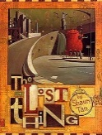  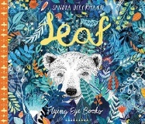 | 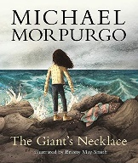 |  | 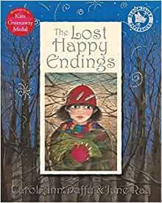 |  |  | 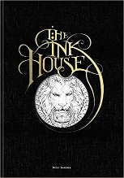 |  |  | 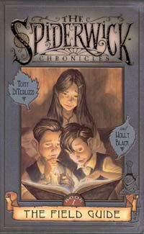 |  |  |  | 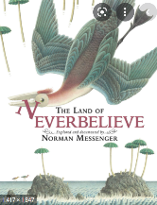
Leaf by Sandra Dieckmann  The Lost Thing by Shaun Tan | The Giant’s Necklace  by Michael Morpurgo |  | The Lost Happy Endings  by Carol Ann Duffy |  |  | The Ink House  by Rory Dobner |  |  | The Spiderwick Chronicles field guide  by Tony Diterlizzi and Holly Black |  |  |  | The Land of Neverbelieve  by Norman Messenger
Writing focuses  Basic skills and stamina  Narrative  Non-chronological report | Writing focuses  Narrative  Newspaper Report |  | Writing focuses  Narrative  Biography |  |  | Writing focuses  Short Writing Tasks  Formal and Informal writing |  |  | Writing focuses  Narrative |  |  |  | Writing focuses  Narrative  Non-Chronological Report
Core text used across the curriculum

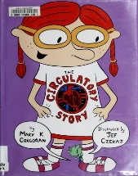 | 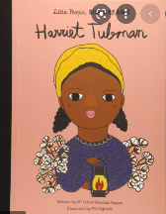 | 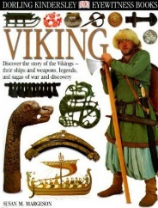 |  |  | 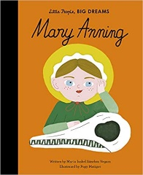 |  | 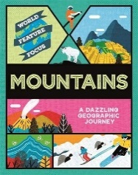 |  |  | 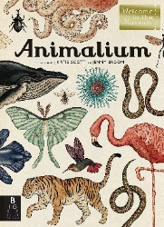 |  |  |  | 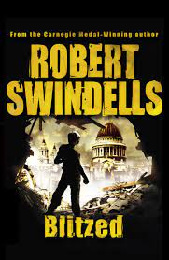
The Circulatory Story  by Mary K. Corcoran | Little People Big Dreams  Harriet Tubman | Dorling Kindersley Vikings |  |  | Little People Big Dreams  Mary Anning |  | Mountains  A Dazzling Geographic Journey |  |  | Animalium: (Welcome To The Museum) |  |  |  | Robert Swindells  Blitzed
Science  The Art of Being Human | Black History Month | History  Vikings |  |  | Science  Evolution and Inheritance |  | Geography  Mountains |  |  | Science  Animal Classification |  |  |  | History  World War 2
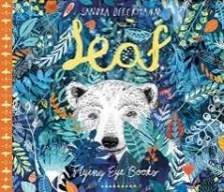 |  | 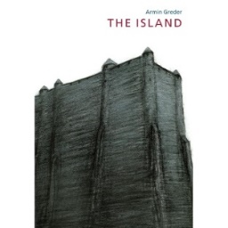 |  |  |  |  | 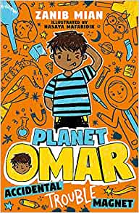
Leaf  by Sandra Dieckmann |  | The Island  by Armin Greder |  |  |  |  | Planet Omar: Accidental Trouble Magnet  Book  by Zanib Mian
PSHE |  | PSHE |  |  |  |  | PSHE
Class Novels

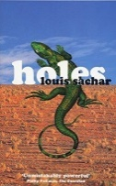 | 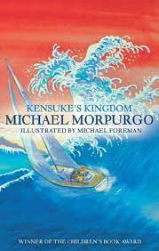 |  | 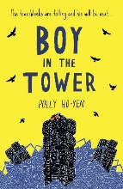 |  |  | 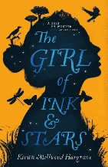 |  |  | 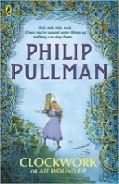
Holes  by Louis Sachar | Kensuke’s Kingdom  by Michael Morpurgo |  | The Boy in the Tower  by Polly Ho Yen |  |  | The Girl of Ink and Stars  by Kiran Millwood Hargrave |  |  | *Clockwork  by Philip Pullman |  |  |  | *Blitzed  by Robert Swindells
Curriculum Drivers  Resilience – determination  Community – serving others and friendship | Curriculum Drivers  Resilience- bravery  Community – diversity and friendship |  | Curriculum Drivers  Resilience - bravery  Community – supporting each other |  |  | Curriculum Drivers  Aspiration – hopes and dreams |  |  | Curriculum Drivers  Resilience - consequences of a lack of perseverance |  |  |  | Curriculum Drivers  Community – war (home front) and diversity
Author Study

Polly Ho Yen | Michael Morpurgo |  | Philip Pullman |  |  | Kiran Millwood Hargrave |  |  | Robert Swindells |  | Louis Sachar
Poetry
Friends  Benjamin Zephaniah | ‘Twas the Night Before Christmas  Clement Clarke Moore |  |  | The Giantess  Carol Ann Duffy |  | Still I Rise  Maya Angelou |  | Problems With Hurricanes  Victor Hernandes Cruz |  |  |  | *The Jabberwocky  Lewis Carol
*The 5 Plagues of the Developing Reader https://teachlikeachampion.com/wp-content/uploads/5-Plagues-Reading-Spine.pdf
Archaic Language | Just William by Richmal Crompton (cracking comprehension) and Blitzed by Robert Swindells
Non-Linear Time Sequences | Clockwork by Philip Pullman and Blitzed by Robert Swindells
Narratively complex | Clockwork by Phillip Pullman
Figurative/Symbolic Text | The Lost Thing by Shaun Tan
Resistant Text | Jabberwocky by Lewis Carroll

The order in which texts are studied may change.

